LAB NO # 3

OBJECTIVE: To learn query execution in OLTP databases*.*

*TASK 1*

Event:

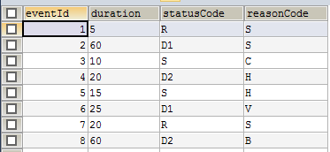

Status:

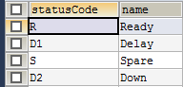

Readyreason:



Sparereason:



Delayreason:



Downreason:



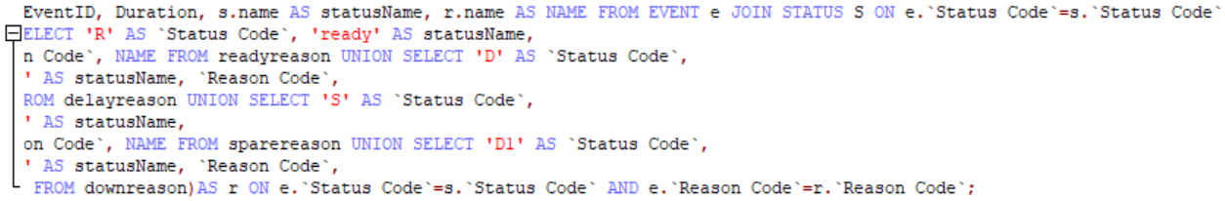

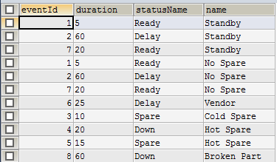

*TASK 2*

1. Write An SQL Query To Fetch “FIRST_NAME” From Worker Table Using The Alias Name As <WORKER_NAME>.

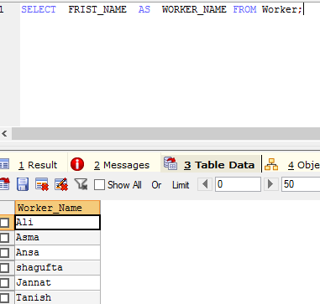

1. Write An SQL Query To Fetch “FIRST_NAME” From Worker Table In Upper Case.

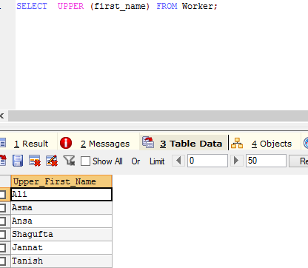

3 Write An SQL Query To Fetch Unique Values Of DEPARTMENT From Worker Table

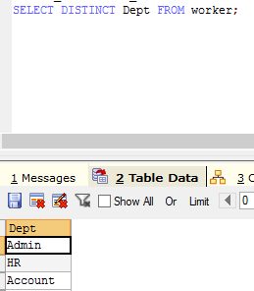

4 Write An SQL Query To Print Last Three Characters Of  FIRST_NAME From Worker Table.

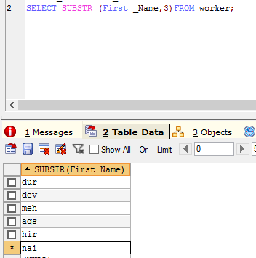

1. Write An SQL Query To Print The FIRST_NAME From Worker Table After Removing White Spaces From The Left Side.

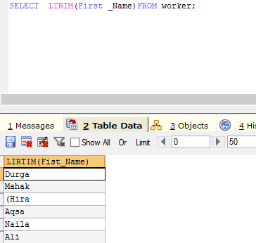

1. Write An SQL Query To Print The FIRST_NAME From Worker Table After Replacing ‘a’ With ‘A’.

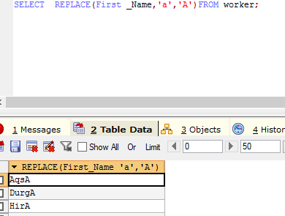

1. Write An SQL Query To Print All Worker Details From The Worker Table Order By FIRST_NAME Descending.

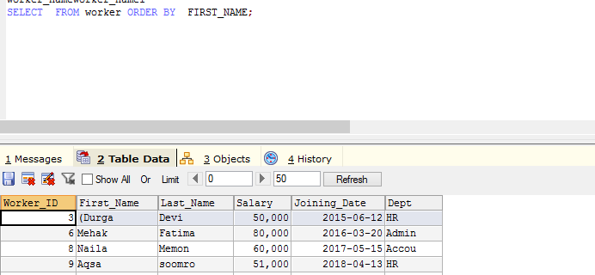

1. Write An SQL Query To Print Details For Workers With The First Name As “Vipul” And “Satish” From Worker Table.

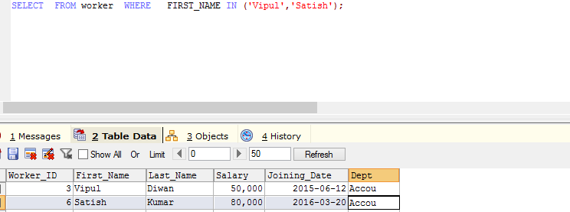

1. Write An SQL Query To Print Details Of Workers With DEPARTMENT Name As “Admin”.

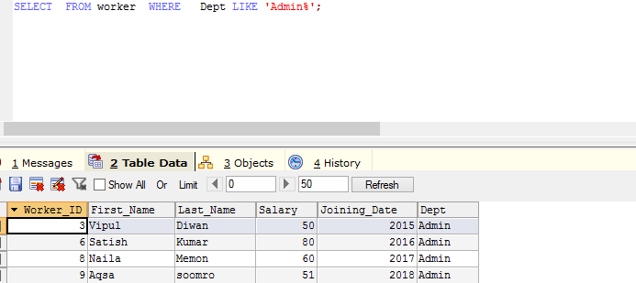

10 Write An SQL Query To Print Details Of The Workers Whose SALARY Lies Between 100000 And 500000

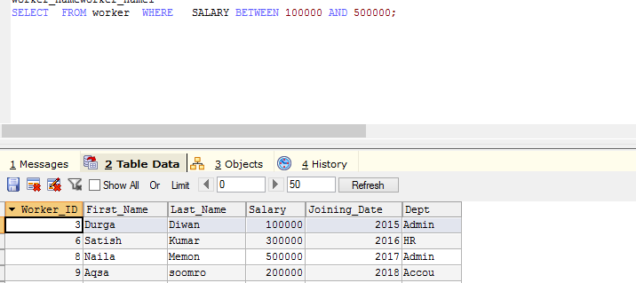

11 Write An SQL Query To Print Details Of The Workers Who Have Joined In Jan’2014.

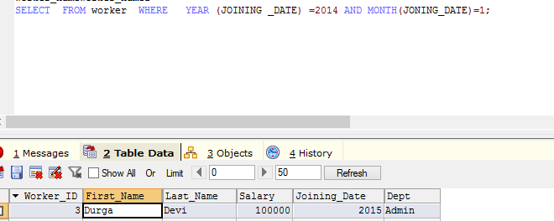

1. Write An SQL Query To Fetch The Count Of Employees Working In The Department ‘Admin’.

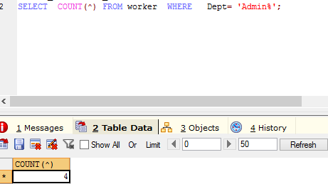

13Write An SQL Query To Fetch The List Of Employees With The Same Salary.

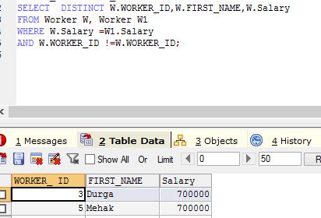

14Write An SQL Query To Show The Second Highest Salary From A Table.

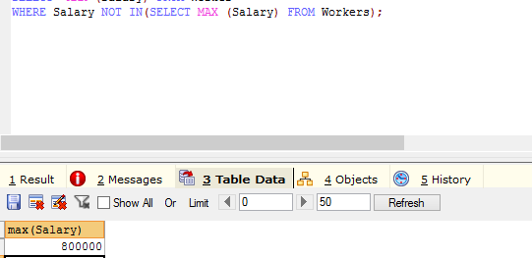

15Write An SQL Query To Fetch The No. Of Workers For Each Department In The Ascending Order

